Fact sheet 3: The Batang coal-fired power plant project in Indonesia
Hozue Hatae, FoE Japan (February 3rd, 2014)

Project Overview
Currently, the Japanese Bank for International Cooperation (JBIC) is considering to fund the Batang coal-fired power plant (2000MW) in Central Java, Indonesia. If built, it will be one of the biggest coal-fired power plants in Asia and will cost approximately 400 billion yen (some US$ 4 billion). Along with JBIC, the Japanese companies J-POWER and Itochu are also major players in the project. In the Japan-Indonesia Summit held in Tokyo last December 2013, Prime Minister Abe confirmed that Japan supports high-efficiency coal-fired thermal power projects, which shows the Japanese government’s intention to promote the project under the public-private partnerships (PPP) scheme.
However, the Batang locals have voiced their concerns about the negative health effects the project will bring as well as the impact it will have on their livelihood which is so heavily dependent on the fertile agricultural land and fishing area. These concerns are not only isolated to the local area but have also reached the capital of Jakarta where a protest was held in front of the Japanese embassy. However, in an attempt to repress the local’s protests, the military and policy took violent action which had resulted in several injuries.

- Power plant specifications: 2,000MW (1,000MW×2 power plants) using Ultra Super Critical (USC) technology (fuel: Indonesian sub-bituminous coal)
- Total cost of the project: Approximately 4 billion USD (approximately 1.3 billion USD investment and 2.7 billion USD loan)
- Project proponents: Bhimasena Power Indonesia (BPI)
  - Subsidiaries: Electric Power Development Company (J-POWER) with a 34% share, Adaro Energy (Adaro) with a 34% share and Itochu Corporation (Itochu) with a 32% share
  - A 25-year power purchase agreement (hereafter referred to as PPA) was signed with the Indonesian State Electricity Company (PLN) using the BOOT scheme.
  - This will be the first PPP project based on an Indonesian Presidential Decree.
- Lending Agency: Japan Bank for International Cooperation (JBIC) as well as private banks (under consideration)
- Certification Agency: Power purchase warranty through the Indonesia Infrastructure Guarantee Fund (IIGF) and the Ministry of Finance etc.
- Project site location: Batang regency, Central Java province (226 hectares)
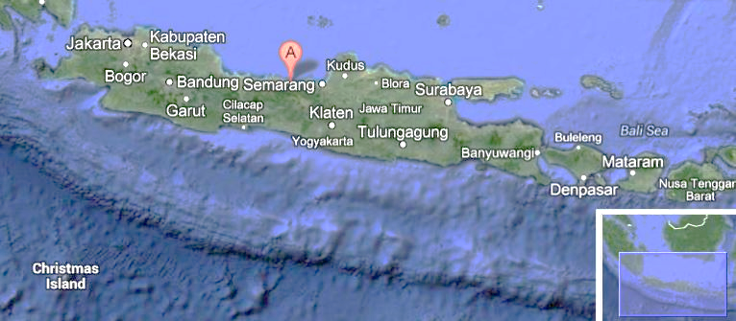
Java Island, Indonesia

Affected people： Farmers (rice, jasmine, etc.), fishers
Main sequence of events:
2011 | June | 3 companies (J-Power, Adaro and Itochu) get priority negotiation rights (new coal-fired power plant independent power producer (IPP) international tender)
 | July | J-Power, Adaro and Itochu establish BPI
 | October 6^{tz} | BPI (for a 25 year PPA) enters into a contract with PLN.  BPI enter into contracts with IIGF and the Indonesian government to guarantee payment obligations
 | July 4th | Locals and citizens’ groups hold a protest in the capital city of Jakarta (in front of the Ministry of Marine Affairs and Fisheries)
2012 | August | Scheduled loan agreement is delayed  BPI and commercial banks enter a 1 year bridge loan agreement
 | October | Deadline for obtaining a loan is extended  Start of construction is delayed
2013 | July 5^{tz} | Locals hold a protest in Semarang, the capital of Central Java province
 | July 11th | JBIC starts an environmental review for the Batang power plant project (The Indonesian language version of the environmental impact assessment report (EIA) become public)
 | End of July | JBIC conduct a site investigation as part of their environmental review of the Batang power plant project
 | July 22nd | Locals and citizens’ groups hold a protest in front of the Japanese embassy in the capital city of Jakarta. They submit a letter to the embassy addressed to Prime Minister Abe stating that “due to the construction of the Batang coal-fired power plant by 2 Japanese companies, several human rights violations have taken place. These 2 companies have threatened locals, made criminals of local community leaders, destroyed jasmine gardens and have taken away the land that is required for the livelihood of locals.”
 | July 30th | On the construction site of the power plant, the police and military take violent action against approximately 500 locals who demanded an end to the construction of the Batang power plant. Approximately 15 people are injured in the incident.
 | August | The National Commission on Human Rights in Indonesia submit a recommendations report to the Indonesian government concerning the Batang power plant project. In its report, the commission recommends the local police and national military to withdraw from land acquisition negotiations as they could force the sale of land.
 | August 26^{tz} | Indonesian government officials approve the EIA and issue an environmental permit.
 | October 6th | The deadline for obtaining a loan is re-extended
2016 | End of year (approx) | Unit 1 of the Batang power plant to be put in operation (delay is expected)
2017 | Mid-year (approx) | Unit 2 of the Batang power plant is to be put in operation (delay is expected)
The current situation
- The guarantee agreement for the Batang power plant project was signed on October 6th, 2011 and the deadline for loan procurement was set 1 year later for October 6th, 2012 but due to local opposition to the project and failure to secure enough land (only about 80% of the estimated land has been secured), the deadline to acquire enough land was extended 2 years in a row (until 2014).
- Construction was set to begin in October, 2012 and Unit 1 and 2 are planned to begin operations at the end of 2016 and mid-2017 respectively. However, it is expected that operations won’t begin as planned.
- JBIC is still currently conducting the environmental review for this project.

According to a 2012 report (only available in Japanese) by the Ministry of Land, Infrastructure, Transport and Tourism, MLIT, JBIC is funding approximately 60% (1.6 billion USD) of the project and the remainder (approximately1.1 billion USD) is set to be provided by private banks.
In August of 2012, commercial banks entered into 1 year bridge loan contract with a total amount of 270 million USD (Mitsui Sumitomo Trust & Banking Co., Ltd, 135 million USD, Bank of Tokyo-Mitsubishi UFJ, Ltd., 62 million USD and Mizuho Bank, Sumitomo Mitsui Banking Corporation, DBS Bank (Singapore), and OCBC Bank (Singapore), with 18 million USD each).
According to JBIC, there are approximately 500 land owners. There are approximately 1,200 tenants and agricultural workers who are hired on a basis.
http://www.kikonet.org/iken/kokusai/archive/letter20130821.pdf

